**Deadline: 1 week.**

**General Requirements and links:**

* Send conformation about completion to [alindor.tech@gmail.com](mailto:alindor.tech@gmail.com). Conformation should contain: link to GitHub (do not forget to grant access by email above), APK file.
* Add a README file to your repository explaining your work and the challenges you faced.
* In test assignment you need to complete 2 pages of our design in Figma: <https://1drv.ms/u/s!AlpJiFHTWG8ijgfEFSk1h4-2kjQv?e=MByWZS>
* The first page is Google sign-in (via Firebase).
* The second page is “IndRecord”. To avoid confusion, it looks like this:

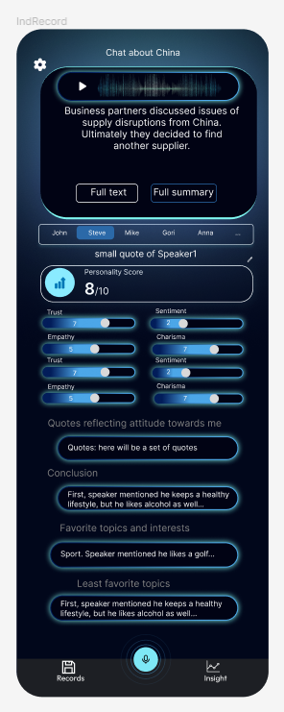

* As a result, you should deliver an APK mobile app with 2 pages, so the Hiring manager will be able to install it on his Android and test.
* In input, the Hiring manager will make an audio record.
* In output, the Hiring manager should be able to play his audio+ get AI insights from OpenAI api.
* <https://1drv.ms/f/s!AlpJiFHTWG8ijT1-_Do-ylWF04fQ>. Feel free to check our current MVP. It may help you in diving deeper in our project.

**Specific Requirements**

1. Utilize the Deepgram API for Speech to Text (free $200 credits without a credit card).

2. Utilize the OpenAI API (to get free credits it requires a $5 one-time top-up, but we, Alindor Corp., committed to refund it upon invoice submission after at least formal execution of Master Mode) to be able to:

3. Provide Full transcription + Summary of transcription. All rest section make hardcoded, so you don’t need to work with prompt for sentiment analysis and get responses for sections 'small quote of Speaker' + Personality score + traits + “Quote reflecting attitude” and below. But you **still need to develop full UI UX frontend** according to the Figma design with hardcoded text and **with dynamic functionality** (especially, extending of text on click). However, please put long hardcoded text to test how it looks on scrolling.

3. Modify UI UX design according to your vision for page “IndRecord” and deploy it. Make it better. No specific requirements, just show your creativity. This paragraph is very important, because we are looking for frontend developer with strong design skills, sense of taste and beauty.

*To honor the time and effort of every applicant, we are dedicated to providing feedback on test assignments within 1 month of their completion, regardless of the outcome. Please be aware that completing the test assignment does not guarantee a job offer or employment.*